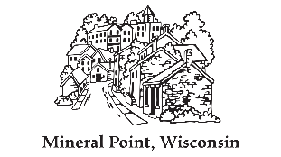
Mineral Point 2026 Pool Pass
City of Mineral Point
137 High Street, Suite 1
Mineral Point, WI 53565
(608) 987-2361

Application Form

Family Pass

Resident: $140.00 Non-Resident: $175.00

Family Name: _______________________________
Address: ____________________________________
Phone Number: ______________________________

**Family passes can only include immediate household members. Grandparents, babysitters, etc. should have their own pass.**

Names of Family Members:
______________________________ | ________________________________
______________________________ | ________________________________
______________________________ | ________________________________
______________________________ | ________________________________
______________________________ | ________________________________

Individual Pass

Resident: $60.00 Non-Resident: $75.00

Name: ________________________________
Address: _____________________________________
Phone Number: _______________________________

For Office Use Only

Date paid_______________ Cash/Check Number___________
Amount Paid_____________ CH Staff Initials____________ Pass Number____________

